Introduction to CloudFormation

CloudFormation is an AWS service which enables you to create, manage, configure, replicate and delete AWS resources easily and rapidly using templates. Creating one or few resources, setting and deleting them when you are done are not so difficult and time consuming, but what if you have to deal with hundreds of them and even in different regions? Creating, setting, and managing **stacks** (collection of AWS resources) can be done in an optimal way, AWS CloudFormation lets you do these processes with **templates**, formatted text files in JSON or YAML.

### **Stacks and Templates**

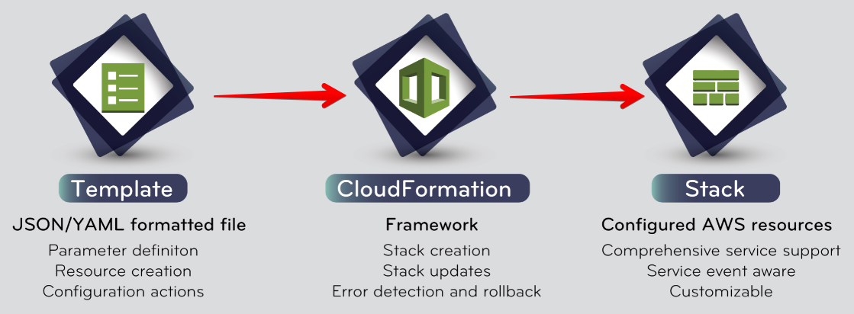

**template** is a JSON or YAML formatted text file which you specify the AWS resources you want to create. Templates can have the extensions .json, .yaml, .template, or .txt. You create resources, define the parameters and configure your settings with templates.

A **stack** on the other hand is a single unit composed of the AWS resources provisioned by CloudFormation. A stack can be either a single EC2 instance or a very complex VPC configuration including hundreds of resources like S3 buckets, databases and NAT Gateways. All of the resources in a stack are defined and configured by the related template.

### **CloudFormation's Working Process:**

First, you create a template using a text editor or AWS CloudFormation Designer (AWS's graphical interface for creating templates). You can also specify a sample template provided by AWS for your project. The template has to describe the resources and the properties of these resources you need in your stack.

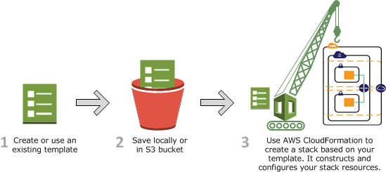

Second, you save your template in an S3 bucket or locally in your computer.

And last, you create a CloudFormation stack by specifying the path of the template file (i.e. a local folder or an S3 URL). You can define parameters to specify input values while the stack is being created.

CloudFormation provisions and configures resources by making calls to the relevant AWS services that are described in your template. You can use your stack after CloudFormation reports it's ready. If the creation of the stack fails somehow, CloudFormation rolls back the changes by deleting the resources created.

You can also update or delete your stack whenever you want.

### **Accessing and Pricing**

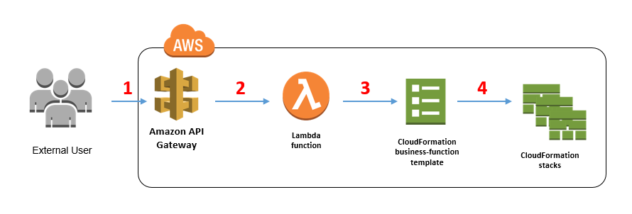

### **Accessing:**

AWS enables you to access CloudFormation via:

* **AWS Management Console**: You can use Management Console to easily access CloudFormation like many other services.
* **AWS Command Line Interface**: You can use also CLI to access CloudFormation. Please check this link if you need more information about [AWS CloudFormation CLI](https://docs.aws.amazon.com/cli/latest/reference/cloudformation).
* **CloudFormation API**: AWS supports accessing CloudFormation via API, if you want to use. Please see [AWS CloudFormation API Reference](https://docs.aws.amazon.com/AWSCloudFormation/latest/APIReference/Welcome.html) for information about making API requests and API actions.

### **Pricing:**

AWS doesn't require any additional fee for using CloudFormation, you only pay for the resources you use. Yet, some third party resource providers might be an exception, please check [AWS CloudFormation Pricing](https://aws.amazon.com/cloudformation/pricing) for more information. If you are a free tier user, you can leverage CloudFormation as if you use the AWS resources manually.